**1.** For each order, list the order number and order date along with the number and name of  
the customer that placed the order. 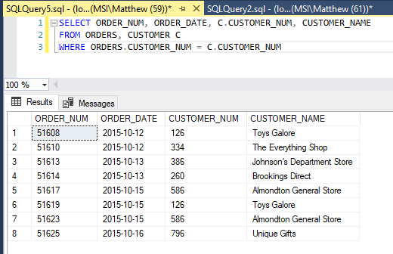

**2.** For each order placed on October 15, 2015, list the order number along with the number and name of the customer that placed the order. 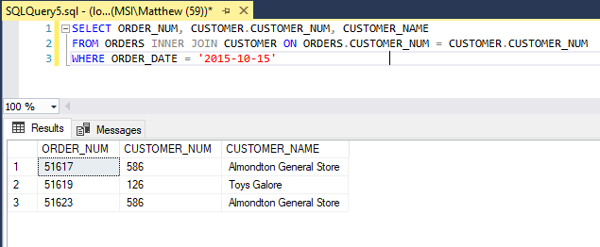

**3.** For each order, list the order number, order date, item number, number of units ordered, and quoted price for each order line that makes up the order. 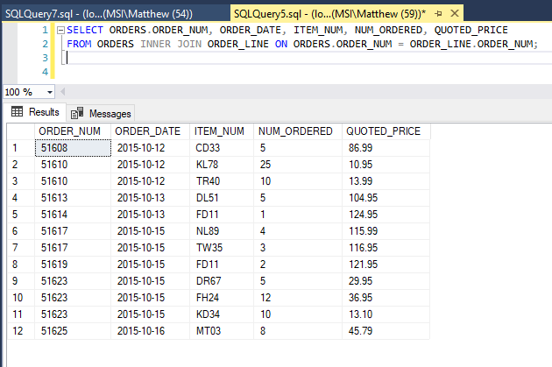

**4.** Use the IN operator to find the number and name of each customer that placed an order on October 15, 2015. 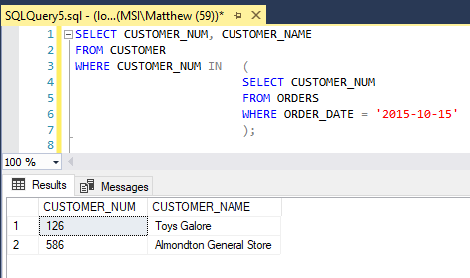

**5**. Repeat Exercise 4, but this time use the EXISTS operator in your answer. 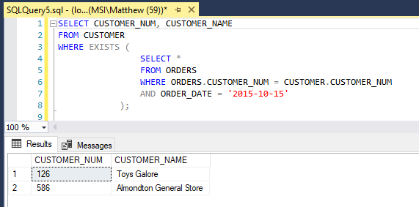

**6.** Find the number and name of each customer that did not place an order on October 15, 2015. 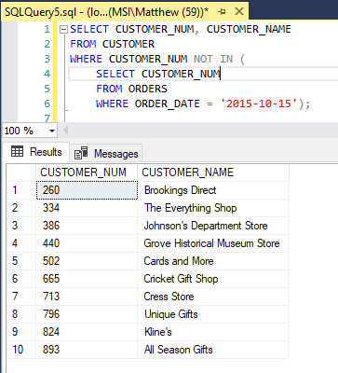

**7**. For each order, list the order number, order date, item number, description, and category for each item that makes up the order. 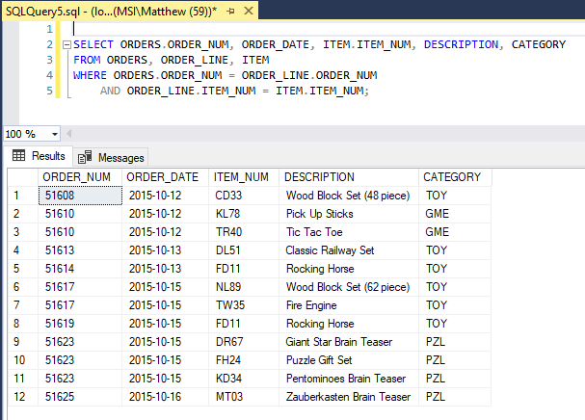

**8.** Repeat Exercise 7, but this time order the rows by category and then by order number. 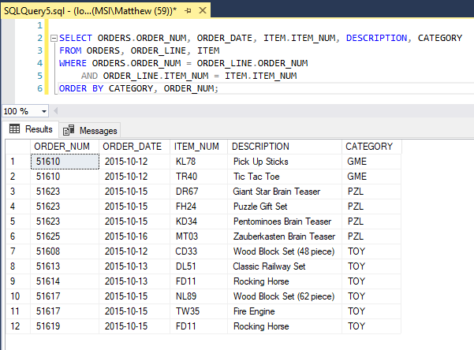

**9.** Use a subquery to find the rep number, last name, and first name of each sales rep who represents at least one customer with a credit limit of $10,000. List each sales rep only once in the results. 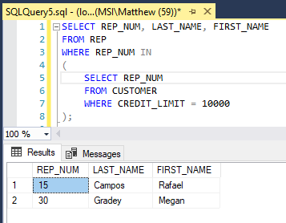

**10.** Repeat Exercise 9, but this time do not use a subquery. 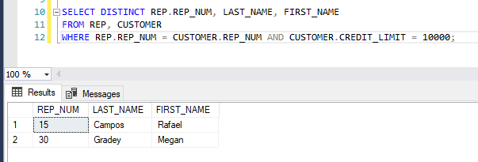

**11.** Find the number and name of each customer that currently has an order on file for a Rocking Horse. 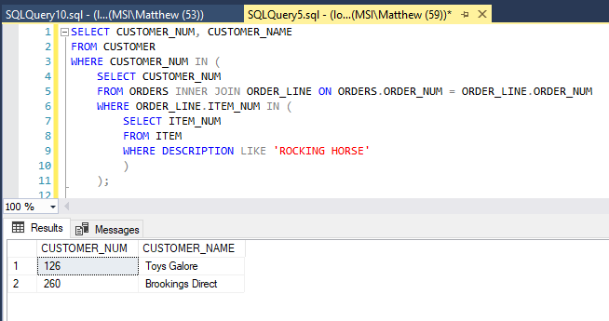

**12**. List the item number, description, and category for each pair of items that are in the same category. (For example, one such pair would be item CD33 and item DL51, because the category for both items is TOY.) 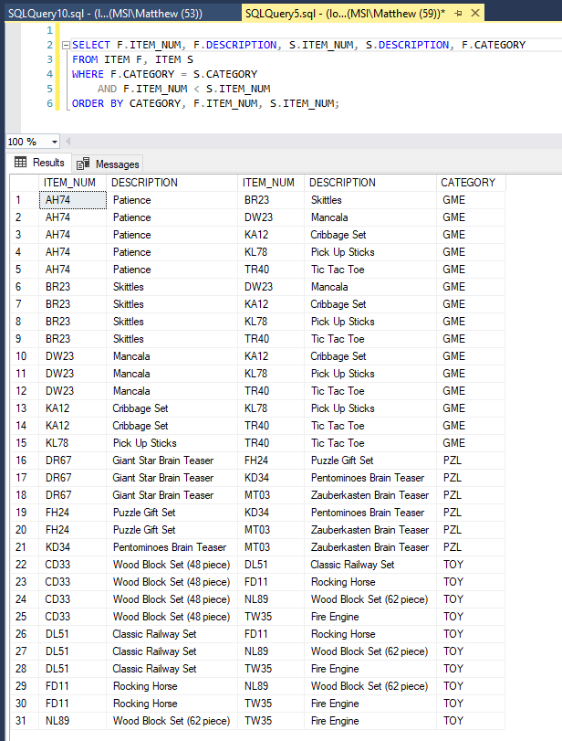

**13.** List the order number and order date for each order placed by the customer named Johnson’s Department Store. (Hint: To enter an apostrophe (single quotation mark) within a string of characters, type two single quotation marks.) 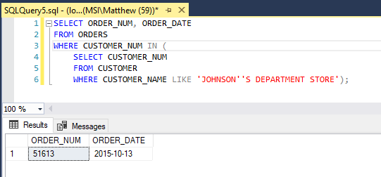

**14**. List the order number and order date for each order that contains an order line for a Fire Engine. 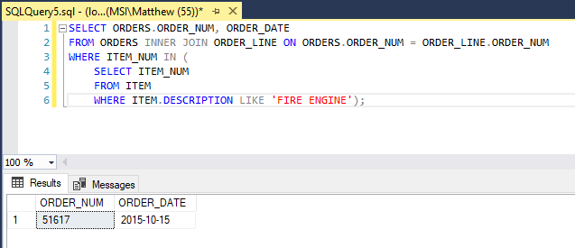

**15.** List the order number and order date for each order that either was placed by Almondton General Store or that contains an order line for a Fire Engine. 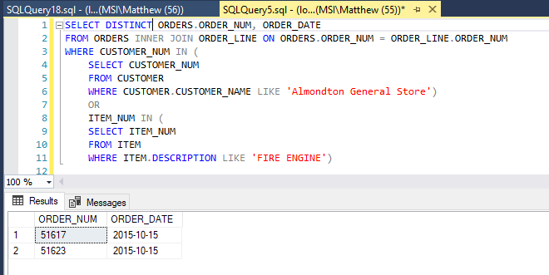

**16.** List the order number and order date for each order that was placed by Almondton General Store and that contains an order line for a Fire Engine. 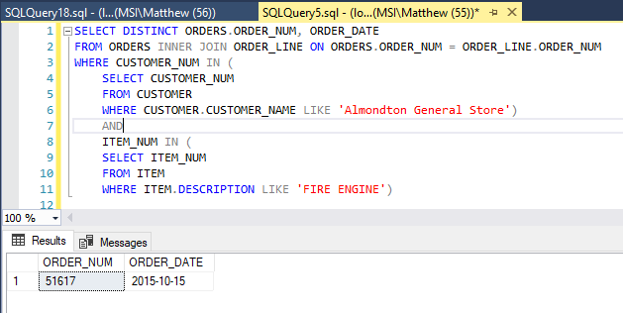

**17.** List the order number and order date for each order that was placed by Almondton General Store but that does not contain an order line for a Fire Engine. 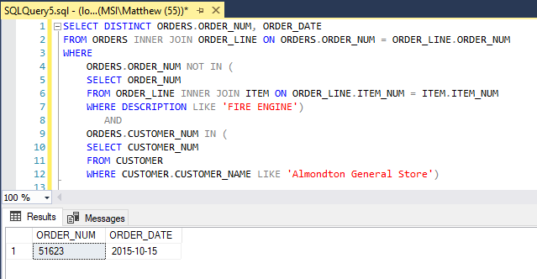

**18.** List the item number, description, unit price, and category for each item that has a unit price greater than the unit price of every item in category GME. Use either the ALL or ANY operator in your query. (Hint: Make sure you select the correct operator.)

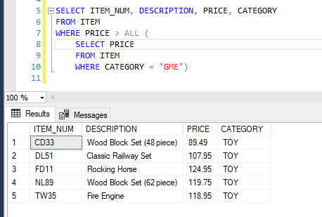

**19.** For each item, list the item number, description, units on hand, order number, and number of units ordered. All items should be included in the results. For those items that are currently not on order, the order number and number of units ordered should be left blank. Order the results by item number. 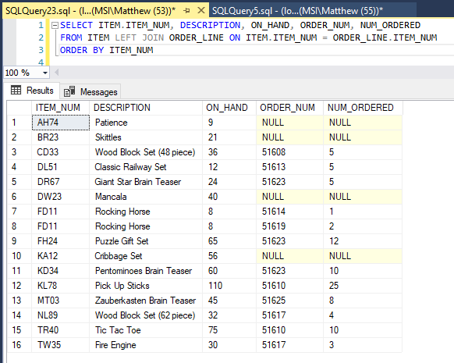

**20.** If you used ALL in Exercise 18, repeat the exercise using ANY. If you used ANY, repeat the exercise using ALL, and then run the new command. What question does the new command answer? 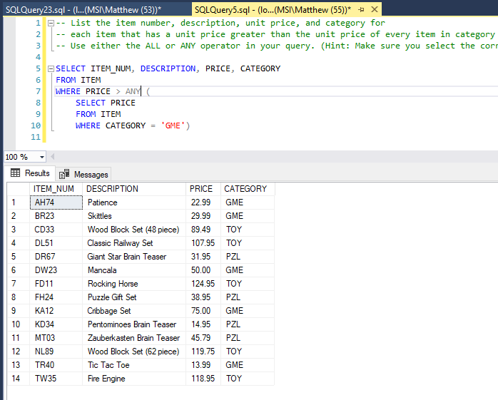

**This query answers the question “What items are greater than ANY of the GME items.” This will match all items that are greater than GME’s least expensive item.**